Sound Advice

by Amin Musani, Au.D.
A10052

I watched as the next IDPA shooter stepped up to the firing line. You could tell he had done this before. He carefully but purposefully loaded a magazine into his handgun and chambered a round. On cue, he drew and shot a perfect score in amazing time. His handgun seemed like an extension of his arm. The bullets landed exactly where he willed them to on the cardboard target. After safely holstering he stepped back, turned around and flashed a smile, which told you he was pleased with his results and all that training and endless hours of practice had finally paid off. As he made it back to the observer area I walked over and congratulated him for a job well done. Curious as to what type of handgun he was using I asked him, “What kind is it?” He replied, “Its 2:30pm.”

It never ceases to amaze me the high number of shooters that I come in contact with that do not wear any type of hearing protection while shooting. Granted, some things in our lives we cannot control. However, noise induced hearing loss (NIHL) and Acoustic Trauma are phenomenon that we most certainly do have control over and yet many shooters ignore the very basic principle of wearing hearing protection.

When is firearm noise is too much? When do we cross that line between loud and damagingly loud? Table 1 displays some of the decibel (dB) levels of various sounds found in our daily lives. A decibel is a unit of measurement and for our purposes here it is measured on a logarithmic scale and there is a 10-fold increase in noise energy for each 10 dB increase. Said another way, an increase of 10 dB doubles the loudness level.

Table 1. Comparing environmental sounds
dB dB
Rocket Launching Pad 180 Average Factory 80-90
Jet Plane 140 Credit Card Verifier 85
Gunshot Blast 140 Noisy Restaurant 80
Riveting Steel Tank 130 Busy Traffic 75
Automobile Horn 120 Conversation Speech 66
Sandblasting 112 Average Home 50
Woodworking Shop 100 Quiet Office 40
Subway 90 Soft Whisper 30

Sounds over 140dB can cause pain and prolonged exposure to noise over 85-90dB can result in permanent hearing loss. Gunfire may be categorized as an impulse noise, which has the characteristic of an explosive burst. Impulse noise of sufficient intensity and pressure is often a cause of acoustic trauma. Generally, studies have shown that such impulse sounds may result in the shifting, skewing, bending, swelling, bursting, tearing, fusing &/or severe mechanical damage to the inner ear cells, structures, and auditory pathways. That is, short-duration sounds of sufficient intensity (e.g., a gunshot or explosion) may result in an immediate, severe, and permanent hearing loss, which is termed acoustic trauma. The degree of hearing impairment seen after acoustic trauma varies and may range from a mild to profound hearing loss. Figure 1 (Pickles & Heumen; 2001) compares electron microscopy of normal, healthy outer hair cells (specialized hearing cells in our inner ear) to damaged ones. Once such damage occurs, it is permanent. There is no method of regenerating these cells or “curing the damage.” Bear in mind that this is only one site where such damage can occur from noise exposure along our auditory pathway.

There is evidence to suggest that once deterioration of certain specialized hearing cells (spiral ganglion cells) has begun, there is a corresponding deterioration within the central nervous system at areas higher up in the auditory system (Kim et al., 1997; Morest et al., 1998). Thus, once damage has occurred at lower levels it is not isolated there but rather may progress upwards through the auditory pathway. This is very characteristic of impulse noise such as gunfire that causes acoustic trauma. The inner ear, then, is not the only structure at risk from such exposure.

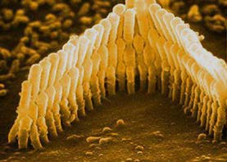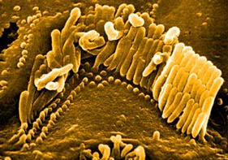
Figure 1. Normal, healthy outer hair cells (L) vs. damaged outer hair cells (R).

Virtually all of the structures of the ear and hearing system can be damaged from gunfire noise (NIH Consensus Statement; 1990). Generally, for sound levels below 140 dB, different types of sounds produce the same hearing loss. This does not appear to be the case at levels above 140 dB, where impulse noise creates more damage than would be predicted. This may imply that impulse noise above a certain critical level results in acoustic trauma from which the ear cannot recover (NIH Consensus Statement; 1990).

Exposure to noise between 90 and 140 dBA (dBA denotes a decibel measure made with a filter that adjusts for human auditory sensitivity) damages the inner ear metabolically rather than mechanically and causes injury depending on the level and duration of exposure. Noise-induced hearing loss, in contrast to acoustic trauma, develops slowly over years, and is caused by any regular and consistent exposure exceeding a daily average of 85-90 dBA (Clark & Bohne; 1999). Acoustic trauma may occur from just one unprotected exposure to gunfire noise.

For sounds between 75 - 90 dBA, the ear has a natural protective mechanism to reduce its sensitivity to low frequency impact sounds through what is termed the middle ear reflex. Generally speaking, muscles in our middle ear contract and stiffen three tiny bones (the smallest bones in the human body called ossicles; see Figure 2) that relay sound to the inner ear. However, a delay of 300 to 500 milliseconds is required to set this protection fully in operation. Most naturally occurring impact sounds can easily be dealt with by the middle ear, but many man-made sounds, such as explosions from guns, as well as certain industrial noises, occur so quickly that our middle ear protective mechanism cannot respond quickly enough. The hearing loss caused by such sounds is permanent acoustic trauma (Truax; 1999).

Peak sound levels from rifles and shotguns can range from 132 dB SPL (sound pressure level is another unit of measurement) for small-caliber rifles to more than 172 dB SPL for high-powered firearms. Americans collectively own more than 230 million guns, and more than half of men in the American industrial workforce occasionally use guns. The National Rifle Association estimates that 60 to 65 million Americans collectively own more than 230 million guns. Because guns are so prevalent in our culture, shooting firearms is the most important source of excessive noise outside the workplace. The severity of injury produced by impulsive noise exposure and the prevalence of shooting by Americans makes gun noise America's most serious non-occupational noise hazard The acoustic energy in a single report from a high-powered rifle or shotgun is equivalent to almost 40 hours of continuous exposure at 90 dBA. In other words, 1 bullet equals 1 week of hazardous occupational noise exposure. An avid target shooter can be exposed to an entire year's worth of hazardous occupational noise in just a few minutes (Clark & Bohne, 1999; NRA, 1999).

What about firearms themselves? Is a .22LR any better on your ears than a .45ACP? Table 2 compares the dB levels of various cartridges.

Table 2. SHOTGUN NOISE DATA (DECIBEL AVERAGES)
.410 Bore 28" barrel 150dB
26" barrel 150.25dB
18 " barrel 156.30dB
20 Gauge 28" barrel 152.50dB
22" barrel 154.75dB
12 Gauge 28" barrel 151.50dB
26" barrel 156.10dB
18 " barrel 161.50dB

CENTERFIRE RIFLE DATA
.223, 55GR. Commercial load 18 " barrel 155.5dB
.243 in 22" barrel 155.9dB
.30-30 in 20" barrel 156.0dB
7mm Magnum in 20" barrel 157.5dB
.308 in 24" barrel 156.2dB
.30-06 in 24" barrel 158.5dB
.30-06 in 18 " barrel 163.2dB
.375 18" barrel with muzzle brake 170 dB

CENTERFIRE PISTOL DATA
.25 ACP 155.0 dB
.32 LONG 152.4 dB
.32 ACP 153.5 dB
.380 157.7 dB
9mm 159.8 dB
.38 S&W 153.5 dB
.38 Spl 156.3 dB
.357 Magnum 164.3 dB
.41 Magnum 163.2 dB
.44 Spl 155.9 dB
.45 ACP 157.0 dB
.45 COLT 154.7 dB

Recall that sounds over 85-90 dB can lead to permanent hearing damage without hearing protection. As can be seen from Table 2, even firing a .22LR (134 dB) has the potential of causing permanent, irreversible, inner ear damage.

There are various kind of hearing loss. Conductive hearing loss refers to physical damage, infection or fluid build up in the middle ear cavity (Figure 2). If the gunblast is of sufficient intensity a conductive loss may be seen and accompanied by such symptoms as eardrum rupture or middle ear bone damage.

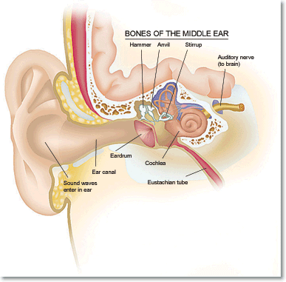

Outer Ear
Middle Ear
Inner Ear

Figure 2. Anatomy of the ear

Conductive losses are typically open to medical treatment from a physician who specializes in diseases of the ear (Otologist or Otolaryngologist). Sensorineural hearing loss refers to damage within the inner ear. This is usually, incorrectly, referred to as “nerve type deafness” which really only occurs in about 1% of the American population (Mueller and Hall, 1998). Sensorineural hearing loss is the most common type of hearing loss in America and noise induced hearing loss or acoustic trauma from firearms is typically sensorineural. It is permanent, irreversible and with proper hearing protection, can be avoided or minimized.

Probably the most common excuse I have heard from shooters is that “my ears have toughened up from shooting and I don’t have to wear hearing protection.” Well, I’m sorry to say that this is not possible. What is more likely is that you have sustained sensorineural hearing loss and some sounds just don’t seem as loud any longer (along with speech). However, it is still critical to wear hearing protection as the hearing you do have left can still be harmed from unprotected firearm exposure. As researchers and educators have noted, “Ears don’t get tough, they get deaf” (Mueller & Hall, 1998).

Typically, noise induced hearing loss and acoustic trauma affect the high frequencies first. Our ears respond to sounds across a wide range of frequencies, from about 20 to
20 000 Hertz (Hz). Speech frequencies are roughly located between 250-8000 Hz. Low frequencies are used to “hear people” while the highs are what we use to understand what they say. To put it another way, the power of speech (vowels) is located in the low frequency range while the clarity of speech (consonants such as s, k, th, sh, f, th) is located in the highs. High frequency consonants are necessary to maximize speech intelligibility. Noise damage from firearms affects these high frequencies first due to, some believe, anatomical reasons (Mueller & Hall, 1999). Figure 3 depicts an audiogram (record of one’s hearing) of a sensorineural hearing loss typical of shooters.
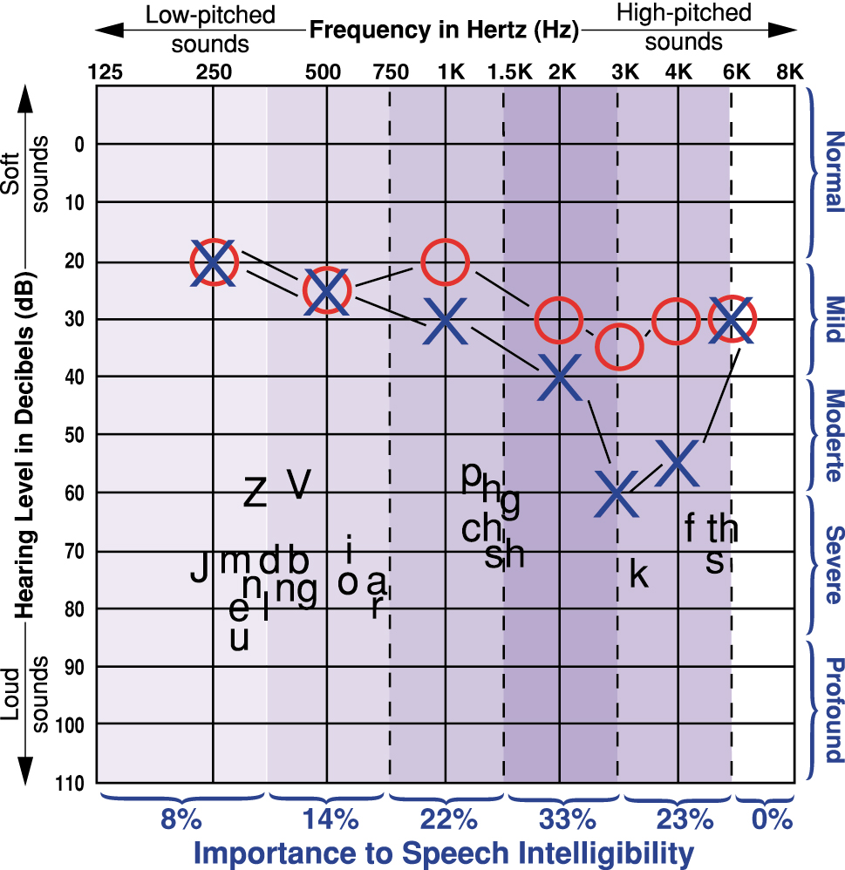

As such, many people complain that “I hear people, but sometimes I don’t understand what they said.” Women’s and children’s voices, typically in the high frequency range, are usually the most difficult to understand when one has such a high frequency hearing loss. Add to all this that our hearing gets worse just from the normal aging process and you quickly realize just how important hearing protection really is.

Other factors also determine how susceptible one is to firearm noise exposure. For examples, blue-eyed individuals may be more susceptible than people with greater melanin content in their eyes. Some studies have shown that males are more susceptible to noise induced hearing loss (NIHL) than females. Newborns and older individuals also seem to be more likely to develop hearing loss from NIHL. Finally, some studies have also shown that smoking increases one’s chances of acquiring hearing loss from noise. This may be due to the carbon monoxide in the smoke (Henderson, Subromaniam, & Boettcher; 1993).

I’ve also noticed that some shooters will wear their hearing protection, but only while shooting. When observing from just a few yards away, they do not wear their hearing protection. This is simply not good hearing conservation practice and is against competition rule #7 of your IDPA manual. In fact, if one was to comply with this rule, anyone within 50 yards of the firing line must wear not only hearing protection, but eye protection also. Some handguns at IDPA produce a very discernible boom that can still damage your ears (see Table 2), even if you are not shooting and are only a few feet to yards away. Of course, this will vary with the type of firearm, cartridge, and distance from the shooter, but Table 2 clearly shows that even a report from a .22 can damage your ears. Though not relevant to IDPA purposes, the use of muzzle brakes and ports dramatically increases the level of noise exposure from firearms. In the consideration of sounds that can damage hearing, one point is clear: it is the acoustic energy of the sound reaching the ear, not its source, which is important. That is, it does not matter if the hazardous sound is generated by a machine in the workplace, by a loudspeaker at a rock concert, by a lawnmower or a firearm during an IDPA event. Significant amounts of acoustic energy reaching the ear may create damage--at work, at school, at home, or during leisure activities. Although there has been a tendency to concentrate on the more significant occupational and transportation noise, the same rules apply to all potential noise hazards, including and especially firearms (Clark and Bohne; 1999).

Sound advice dictates that when at the gun range, by all possible means, take appropriate measures to practice safe gun handling. Wearing hearing protection (along with eye protection) falls into this category, whether you are the shooter or an observer. Think of it this way: hearing aids could cost you anywhere from $600 to $8000 per pair! Wouldn’t you rather spend that on more important things…like firearms, ammunition, training & IDPA?

References

- American Academy of Audiology.
http://www.audiology.org/consumer/guides/aural.php
- Clark, W.W. & B.A. Bohne (1999). Effects of noise on hearing. Medical Student Journal of American Medical Association. May 5th, Vol. 281: 17.
- E.A.R., Inc. (2001). http://www.earinc.com/howhearingworks.html
- Henderson, D., Subromaniam, M., & Boettcher, F. (1993). Individual susceptibility to noise-induced hearing loss. Ear and Hearing, 14(3): 152-156.
- Kim, J., Morest, D.K., and Bohne, B.A. (1997). Degeneration of axons in the brain stem of the chinchilla after auditory overstimulation Hear Res, 103:169-191.
- Kramer, W. Gunfire and Hearing Protection. Ball State University, Muncie, Indiana.
- Mestel, R. (2000). Los Angeles Times. Original print date February 28, 2000. http://www.audiology.org/consumer/guides/aural.php
- Morest, D.K., Kim, J., Potashner, S.J., and Bohne, B.A. (1998). Long-term degeneration in the cochlear nerve and cochlear nucleus of the adult chinchilla following acoustic overstimulation. Micro Res Tech 41:205-216.
- Mueller, H.G. & Hall, J.W. (1998). Audiologists’ Desk Reference. Vol. I Singular Publishing: San Diego
- Mueller, H.G. & Hall, J.W. (1998). Audiologists’ Desk Reference. Vol. II. Singular Publishing: San Diego.
- National Rifle Association (1999). Fact Card. http://www.nraila.org/research/99fctcrd.htm.
- NIH: National Institute of Health Consensus Statement Noise and Hearing Loss. Online 1990 Jan 22-24;8(1): 1-24. http://text.nlm.nih.gov/nih/cdc/www/76txt.html
- Pickles, J., & Heumen, W. (2001). Hearing Unit. Vision Touch and Hearing Research Centre, University of Queensland. http://www.vthrc.uq.edu.au/hearing/hearing_home.html
- Truax, B. (1999). Handbook of Acoustic Ecology (2nd Edition). Cambridge Street Publishing.

Dr. Amin Musani is a Clinical Audiologist practicing in Denison, TX. Any comments or questions may be directed to toc.hear@airmail.net or North Texas Audiology, Morrison Medical Office Bldg., 1014 Memorial Dr., Suite G6, Denison, TX, 75020, 903-416-6281.

Mueller and Hall (1998).
William Kramer, Ph.D.
Mestel, 2000.
E.A.R. Inc.

