

DEPARTMENT OF THE AIR FORCE
AIR FORCE OFFICE OF SPECIAL INVESTIGATIONS
CRIMINAL INVESTIGATIONS DIVISION
ANDREWS AFB, MD 20762-7002

CRIMINAL INFORMATION REPORT (CIR) 02-53

FROM: AFOSI HQ AFOSI/XOGB DATE OF REPORT: 21 October 2002

TO: All AFOSI Regions, Squadrons, and Operating Locations (Cat III)

SUBJECT: Officer Safety Bulletin - Stinger Pen Guns.

SOURCES: Security Specialist Ivan S. Wilson, Defense Reutilization & Marketing Service Office of Command Security (DRMS-DDS); and Michigan State Police Intelligence Division.

SUMMARY: This Criminal Information Report (CIR) is being issued to disseminate an awareness brief for law enforcement personnel regarding easily concealed firearms manufactured by Stinger Manufacturing Corporation (SMC), 562 East Spruce Street, P. O. Box #37, Sault Sainte Marie, MI 49783-0037. The 5.6" stainless steel guns are .22 caliber, single shot, and weigh 5 ounces when empty. The cost is $275.00 for the stainless version and $399.00 for the Limited Edition 24K Gold plate version. Below right is the 18" sniper barrel that the company claims is "all new" and "coming soon". SMC representatives claim that with the new Concealed Carry Weapons (CCW) law in Michigan, the demand for easily concealed firearms is "booming". More photographs and specification on these firearms can been seen at the following SMC web site: http://www.stingerpengun.com
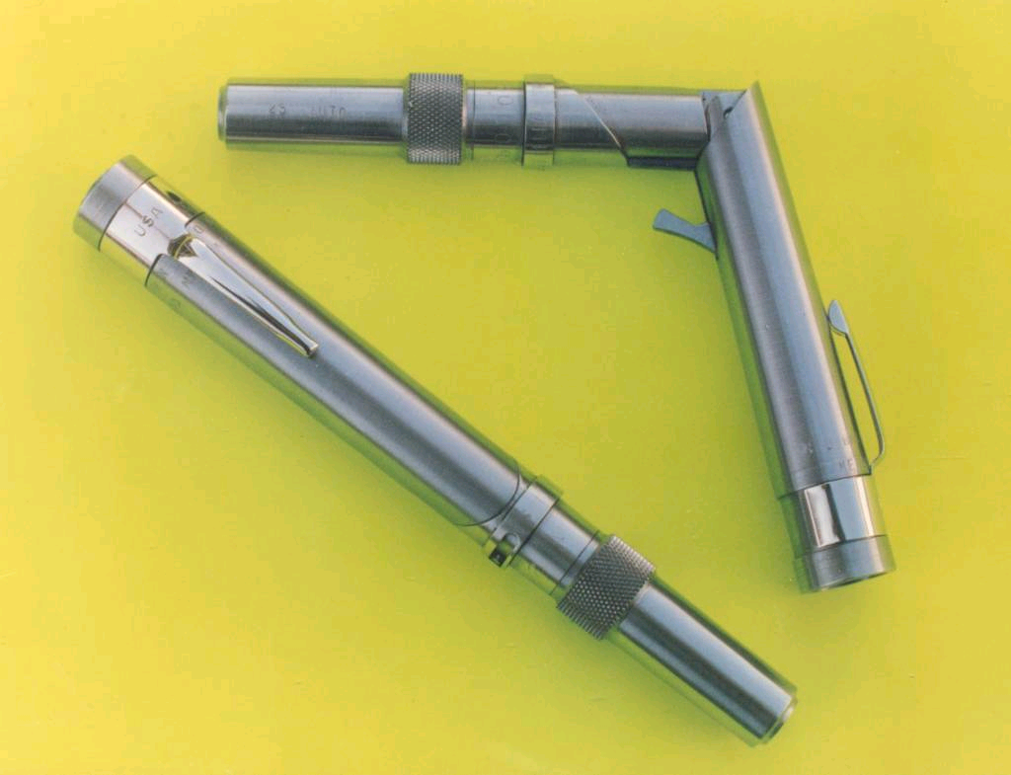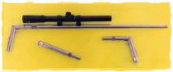
DISTRIBUTION RESTRICTIONS: LAW ENFORCMENT USE ONLY: Disseminate this information to other Military/DoD/Government Criminal Investigative Organizations (NCIS, USACIDC), Security Forces, and local law enforcement.

COMMENTS: This CIR was published as an Officer Safety Bulletin (OSB). OSBs are part of a continuing effort to enhance agent safety and reduce the threat of injury while carrying out law enforcement duties. All law enforcement officers especially those who conduct searches and apprehensions/arrests should be aware of concealed weapons.

LAW ENFORCEMENT SENSITIVE
DO NOT DISSEMINATE OUTSIDE OFFICIAL CHANNELS

HQ AFOSI/XOGB POC: SA Thomas R. Mulconry, HQ AFOSI/XOGB, Andrews AFB, MD, DSN 857-1059; e-mail: thomas.mulconry@ogn.af.mil. For all past CIRs visit the HQ AFOSI/XOG Reading Room located at http://afosiweb.ogn.af.mil/xog/reading.htm.

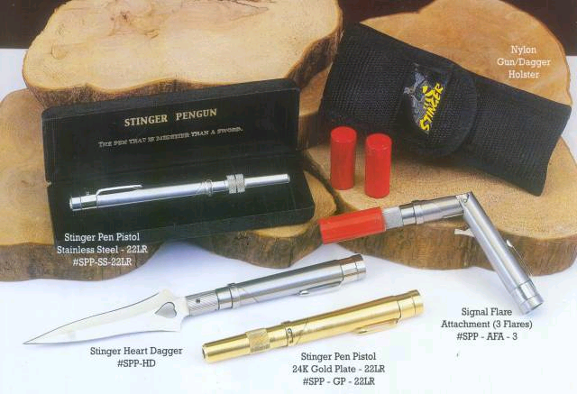

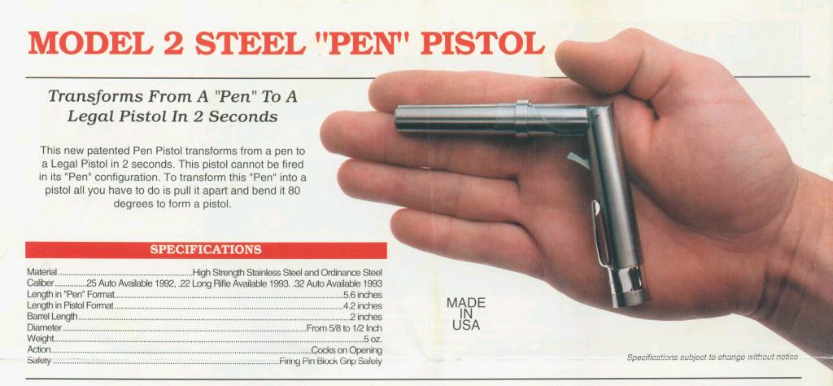
LAW ENFORCEMENT SENSITIVE
DO NOT DISSEMINATE OUTSIDE OFFICIAL CHANNELS
Officer Safety Bulletin - Stinger Pen Guns
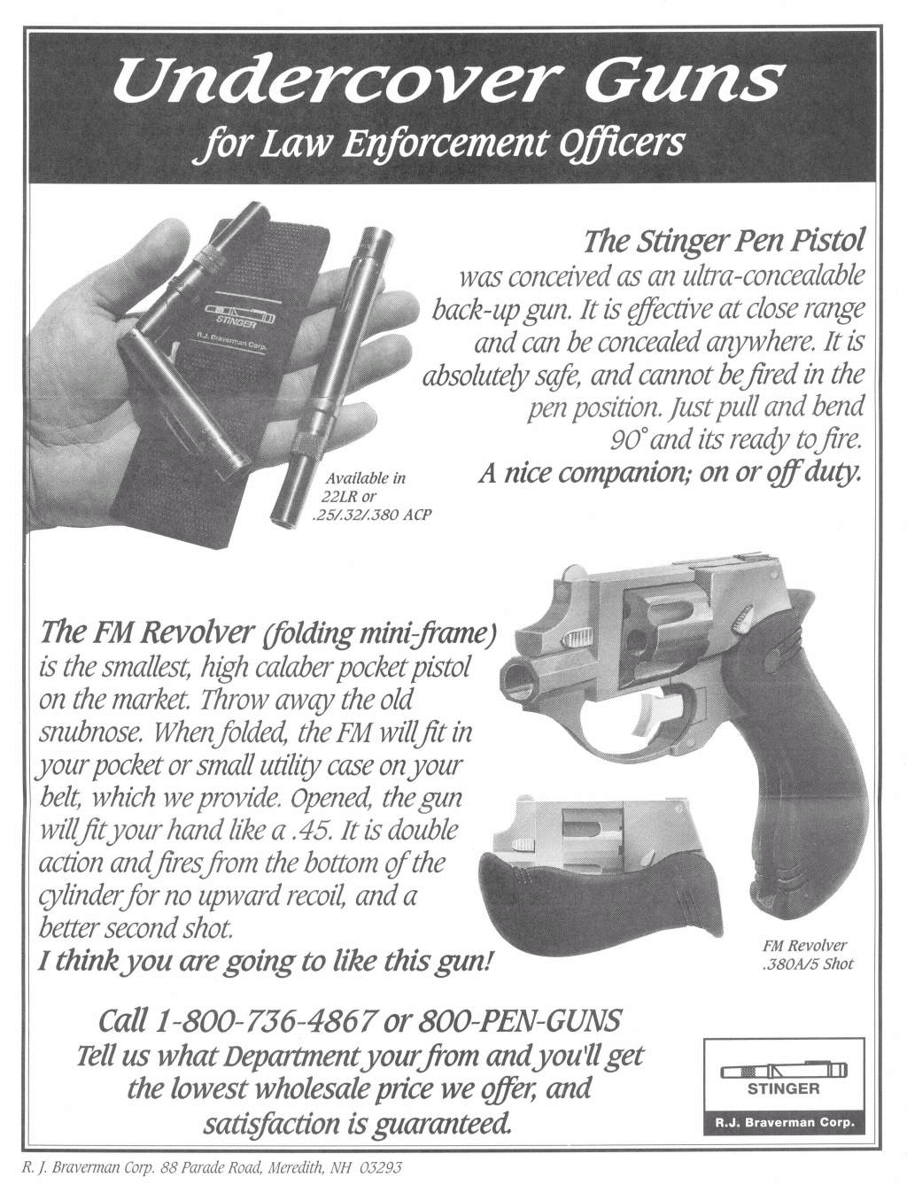
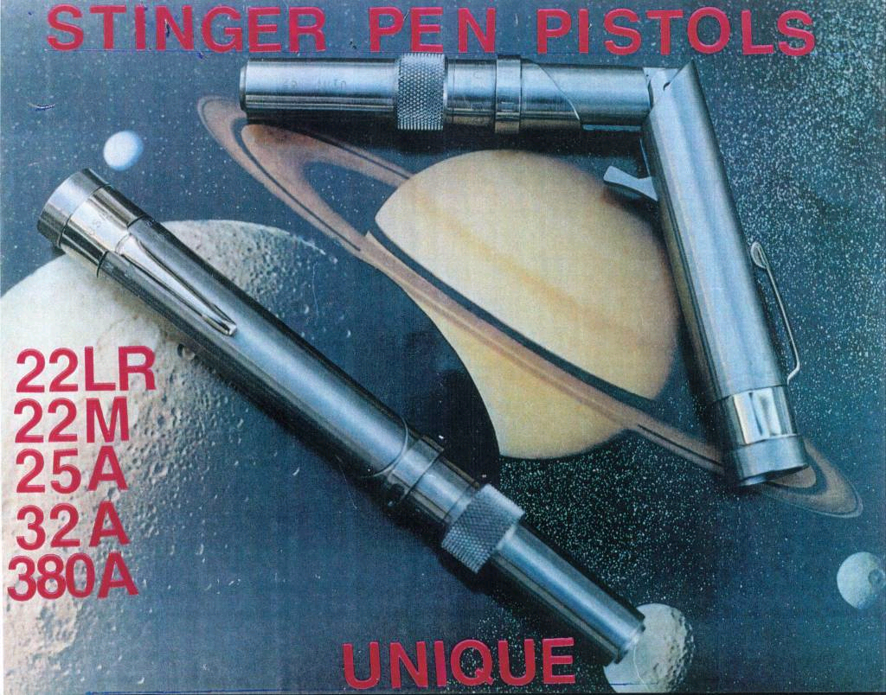

LAW ENFORCEMENT SENSITIVE
DO NOT DISSEMINATE OUTSIDE OFFICIAL CHANNELS

