Contra Costa County Gun Permit Corruption
(or: The Rupf Follies)
By Jim March
jmarch@prodigy.net
February 18, 2002
Introduction
Sheriff Warren Rupf of Contra Costa County, California has financed his re-election efforts with selective issuance of both "CCW" (Carry Concealed Weapons) permits and a "quasi law enforcement status" totally illegal and improper in it's own right.
To understand how this was done, one must review and analyze three separate sources of information:
1) Campaign contribution records available at the County Board of Elections;
2) "Raw data" on CCW permitholders available via Public Records Act and summarized in Appendix A of this document; and
3) A "Sheriff's Posse Of Contra Costa County" newsletter from mid-2001 plus other "Posse insider" documents such as the application forms. As a "bonus", I can also prove that Rupf distributed Posse info and materials through his county offices and employees in a fashion more or less identical to what Gayle Bishop was jailed for.
Index
- Part One: The Posse
- Part Two: Campaign Contribution Data
- Appendix A: Permitholder Database Page

Part 1: The Posse
History
The Contra Costa Sheriff's Mounted Posse had existed as a reserve sworn deputy unit until approximately 30 years ago. Its primary function was horse-mounted search and rescue, no doubt necessary in it's day. As the county urbanized, it's membership of citizens who had to own their own horses necessarily meant that it's members tended to be wealthy.
That in turn made it a campaign contribution goldmine for past Sheriffs.
As the members aged, at some point it was reduced in function to a parade and ceremonial unit still formally associated with the Sheriff's office, while a more modern "mechanized" Search and Rescue team took over those functions.
Several Posse members have told me that somewhere between 25 and 30 years ago, during a parade, a child blew a whistle in a horse's ear and it bolted. It failed to hurdle a parked car, and an elderly Posse member was severely injured (broken neck, per one source). The Sheriff at that time disbanded the Posse as a law enforcement unit…but it remained constituted as a political and social club dedicated to the support of the incumbent Sheriff. As you'll see, it's remaining "law enforcement status" is considerable — and illegal as hell.
The Posse Today
As preparation for my Federal court case in 2001, I had a friend from a wealthy part of the county attempt to gain Posse-related information from the Sheriff's office. Sure enough, he was able to obtain the following two-page Posse application form from the Sheriff's office secretary:
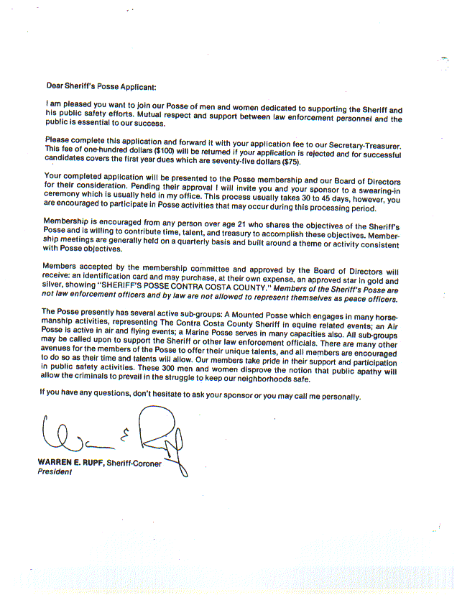
Let's add up the "police-like features" listed on the above-linked letter from the Sheriff: badges, gold stars, an "oath of office" in a "swearing-in ceremony" at the Sheriff's COUNTY offices? (We'll get to the uniforms, ranks such as Lieutenant and more later.)
Do also note that there is a $100 fee and that it covers the first fee of "annual dues," payable yearly, at $75. For people who live in states where $20 will cover your CCW permit for four years, that might seem steep — a nice income stream for the Sheriff, no doubt.
Also, did you catch the part about how successful applicants must be "willing to contribute time, talent and treasury"? [emphasis mine] Golly, if you'll kick in some money, maybe you can exercise your right to self-defense without fear of getting busted and slapped with a felony — how generous. Now let's look at the actual application that came with the Sheriff's letter:
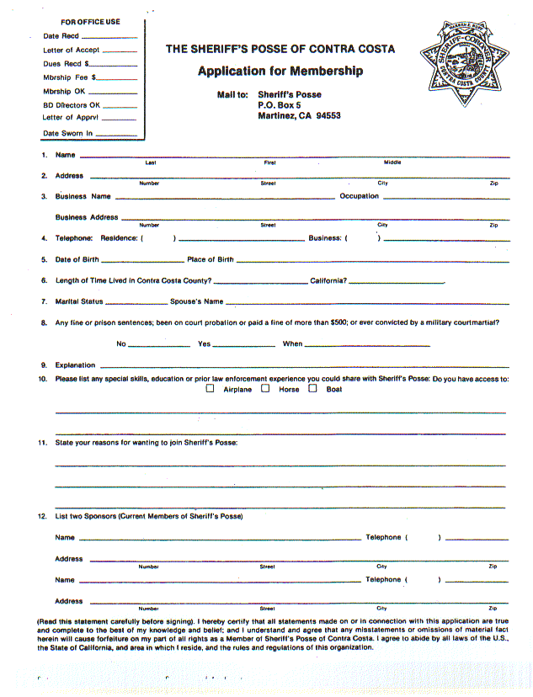
What the heck do members of a political club have to do with sharing "horses, boats or airplanes" with the Sheriff's office!? Note the middle of the application form page.
Also note the use of Rupf's official seal of office on this application form for something his attorneys described in court (twice) as a "private political club". Per the letter, they may be "called upon to support the Sheriff". They're supposed to give "time, talent and treasury" to the "goals of the Sheriff" (apparently including re-election). They get "ID Cards" (not badges?), "Gold Stars", and have a swearing in ceremony (more on those later), yet they're not law enforcement of any sort?
Oh, and a lot of 'em seem to hold CCW permits — see also Appendix A.
You may have noticed the reference to "gold stars" — let me quote a description of the one available in 2000 from an actual Posse member, from his Email to me:
"There was the 2000 'commemorative' badge that was full sized, what 3 inches, maybe bigger?? 7 points, just like the regular uniform badge, saying: 'Sheriff, Contra Costa County', differing from a uniform badge in that the Calif seal in the middle is gold plated, not full color enamel, center is not the seal of the county, but rather that of Calif."
The 7 points identify it to law enforcement as an actual law enforcement insignia, yet per Rupf's letter to prospective Posse, the members "are not law enforcement officers". Hint, wink, nudge...more evidence of law enforcement privileges and trappings for the Posse will become clear later when we look at their newsletter.
I decided to play rough.
The guy who got that set of Posse application materials lived in the wealthy enclave of Kensington, which is outside of any town Rupf has a "zero CCW agreement" with. I figured with that sort of upscale address, Rupf would just love him as a prospective Posse member.
So I had him call up Rupf's COUNTY offices, talk to his secretary, and get the date of the next Posse affair plus get more copies of the Posse application forms as above. (In fact, those forms above are copied from what he received). He then documented the results...for his privacy, his name has been deleted but you can contact my attorney David Beauvais who can confirm the authenticity of this two-page document. Following are the two pages of a signed declaration for my court case:
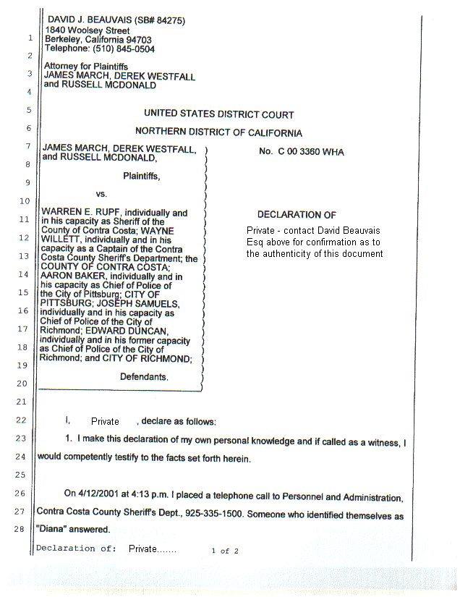
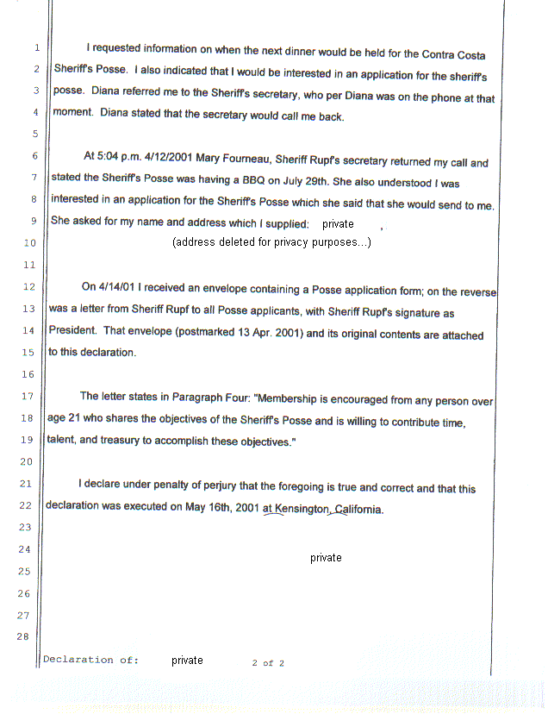
Busted!
If the Posse is a "private political club" in support of the Sheriff, then Rupf's personal secretary had no business knowing the date of their next social function, or how to route an application to the guy from Kensington.
This, ladies and gents, is called "misuse of county personnel and facilities for personal political ends". And it's exactly what former Contra Costa County Board of Supervisors member Gayle Bishop recently lost her job over, plus spent 30 days in the pokey. Sheriff Rupf's jail, come to think. And she was busted by DA Gary Yancey, who as we've seen is Rupf's close buddy. Yancey received campaign contributions from many of the same CCW permitholders who are also Posse as gave money to Rupf.
NOTE: Former Contra Costa County Supervisor Gayle Bishop's convictions for misuse of public funds were related to her use of her county-paid staff and resources for her private law practice and her unsuccessful re-election campaign. Also interesting is the fact that Blackhawk Corp. was fined $26,000 by the Fair Political Practices Commission in connection with contributions to Bishop — and the owner of Blackhawk is a member of Sheriff Rupf's Posse by the name of Kenneth Behring, former owner of the Seattle Seahawks.
So Rupf figured nobody was going to investigate him to the same degree Ms. Bishop was looked into...'cept he forgot about one extra investigator running around loose.
Me.
But he's got another problem too — one of the Posse is very much in favor of widespread self defense, and happened to pass me something quite interesting: a Posse newsletter dated April-June 2001. All six pages of that document follow, with commentary…
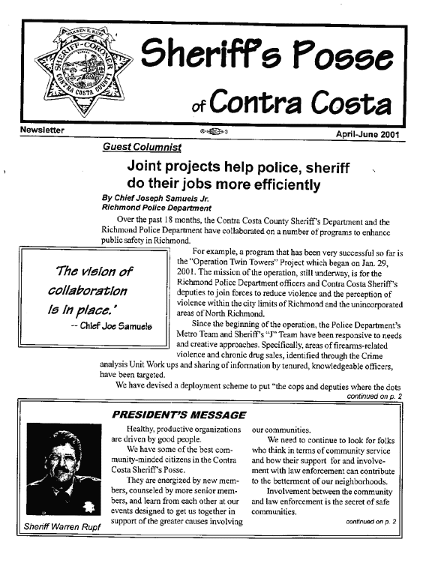
Page one: nothing too odd, except that PD Chief Samuels of Richmond is one of the Chiefs who has requested that Rupf not issue CCW permits in his town — and Samuels clearly knows of the Posse's existence. Whether he knows of the extreme favoritism Posse members receive in CCW is as yet an open question.
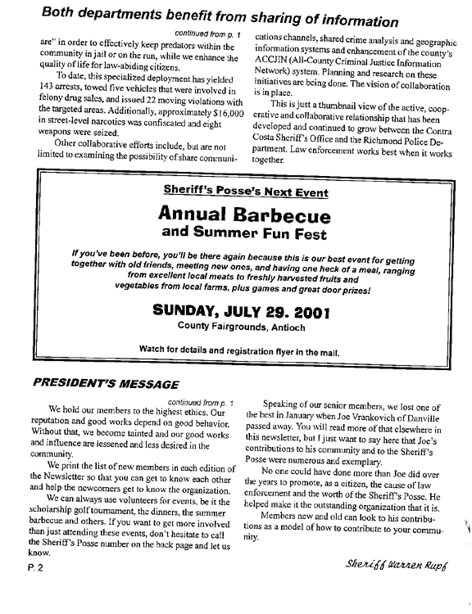
The recently deceased Joe Vrankovich was a CCW permitholder. Rupf asks for volunteers for, among other things, the "dinners" — Posse dinners directly benefited Rupf's campaign fund, as you'll see in the campaign finance statements in part two.
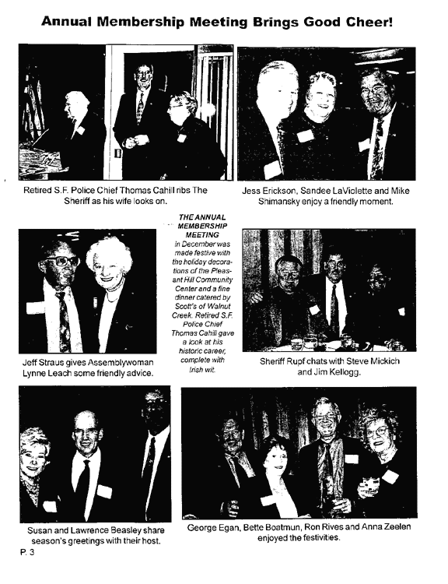
When I complained about the favoritism in CCW issuance being shown to Posse members to my elected representatives, I was ignored. In the case of Senator Rainey, this was to be expected, he was Sheriff before Rupf and ran the Posse then. Shown here is my other elected rep, Assemblywoman Lynne Leach, partying with 'em.
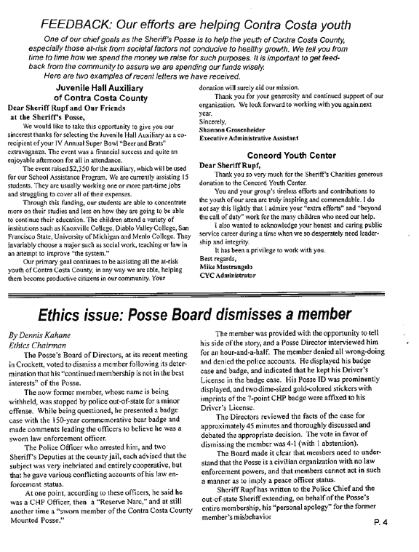
Let's see, they named a benefit event for juvenile hall inmates "Beer and Brats"? I wonder if the kids know?
More seriously, here we have a case of a Posse member trying to pass himself off as a cop. He failed because he was drunk off his rocker, and "gilded the lily" by adding CHP insignia. Except for that, it might have worked.
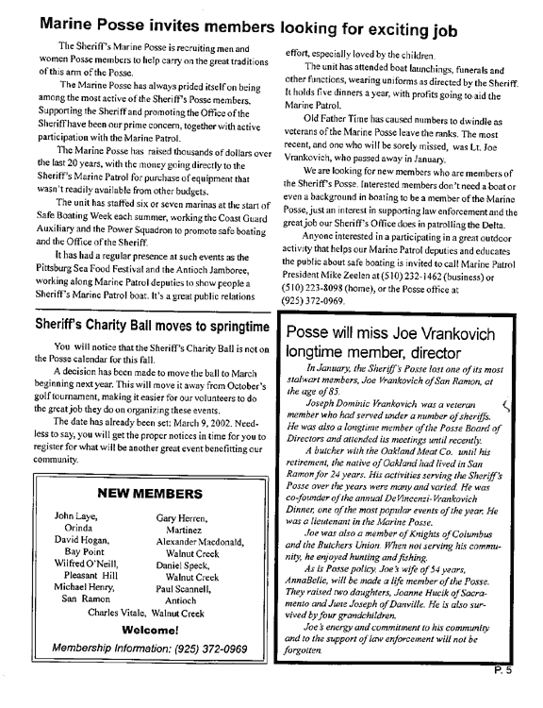
At age 85, Vrankovich's rank of "Lieutenant" couldn't have been as a reservist — that's a POSSE rank. Per the 1st article, the "Marine Posse" has uniforms in which they appear in public. So the Posse has ranks, uniforms, gold stars, ID cards ("badges"), swearing-in ceremonies, easy access to gun carry…and they're not cops? Mike Zeelen holds a CCW permit.
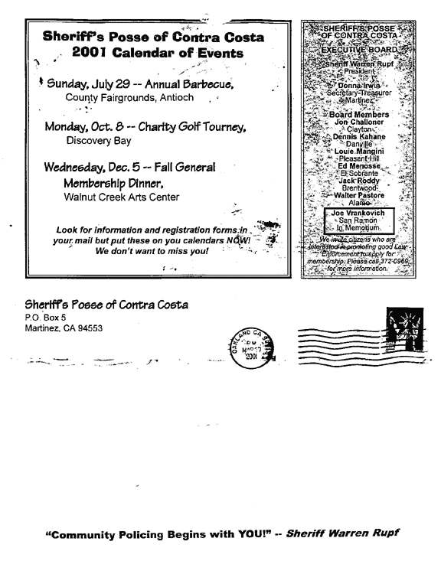
Yo Rupf: give ME a uniform, rank, badge, gold star and legal gun carry and sure, I'll do as much "Community Policing" as you want! And apparently, all it takes is regular campaign contributions?
This is insane. Remember, Rupf keeps the Posse membership lists totally secret, not even the county has access. Yet they're some sort of "quasi cops"?
Of the Board of Directors members listed above, Challoner, Pastore, Kahane and the aforementioned (RIP) Vrankovich have (or had) CCW permits.
Now let's see how the Posse (and CCW permitholders) actually connect to Rupf's campaign finances.

Part Two: Campaign Contribution Data
Campaign Statement, Page 1:
Horizontal (for viewing online)
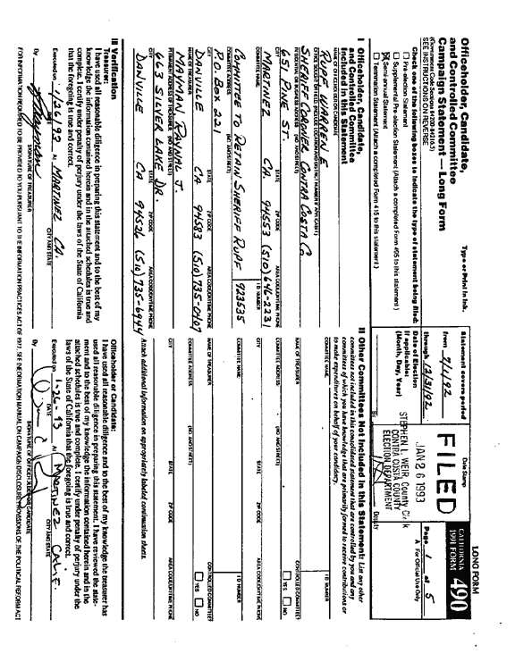
This is a typical "cover page" to each filing made with the County Elections Board. All up through the last time I checked (late 1999) looked the same, with Raynal Mayman as treasurer of the "Committee To Retain Sheriff Rupf". Even the phone numbers are probably current, except that 510 should be converted to 925.
Mayman holds a CCW permit.
Campaign Statement, Page 2:
Horizontal (for viewing online)
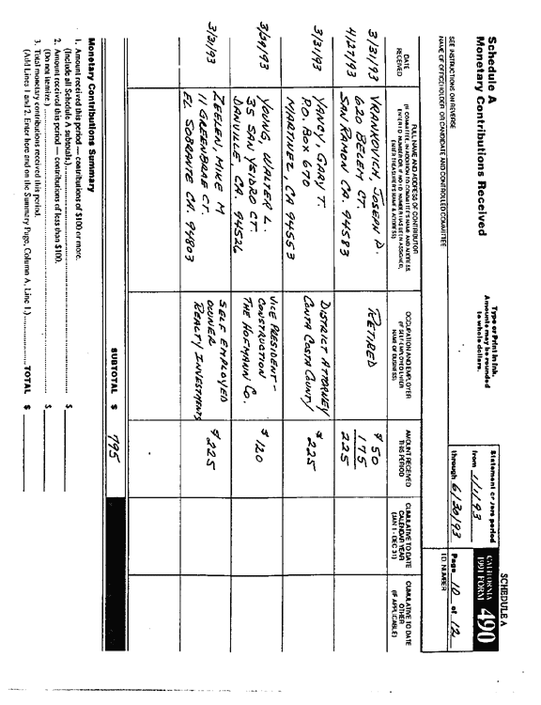
Here we see money coming in to Rupf from Zeelen, who we know is Posse, and Vrankovich (RIP), ditto. Both on the same date, which was a Posse dinner. Also partying and contributing: DA Gary Yancey.
You're going to ask me how I know 3/31/93 was a Posse Dinner, right? See next page…
Campaign Statement, Page 3:
Horizontal (for viewing online)
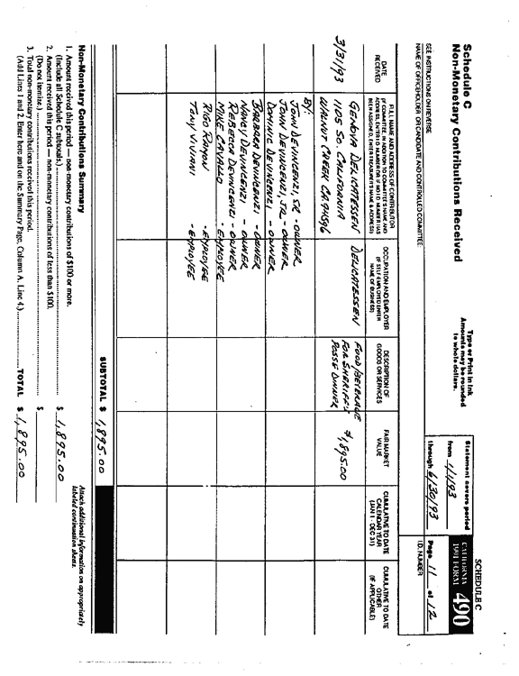
This is how.
The DeVincenzi family owns a local chain of gourmet delicatessens (the Genova Delis). John Sr. (RIP) and John Jr. are CCW permitholders.
Now, according to the Posse newsletter's eulogy to Vrankovich (page 5 of the Posse newsletter), Vrankovich was one of the two co-sponsors of the long-running "Vrankovich/DeVincenzi Posse Dinners". Makes sense, as Vrankovich was an executive at a meat company and the DeVincenzis had the delis.
But after this one reference to the DeVincenzis financing a dinner back in 1993, there are NO other major contributions on this scale recorded in later campaign finance filings.
It would appear that the DeVincenzis and Vrankovich sponsored the dinners "for the Posse" as an organization, instead of recording it all as donations to Rupf as they did back in 1993.
I don't know if this violates campaign finance rules, but someone more qualified should certainly look into the possibility. A copy of this will go to the Fair Political Practices Commission.
Campaign Statement, Page 4:
Horizontal (for viewing online)
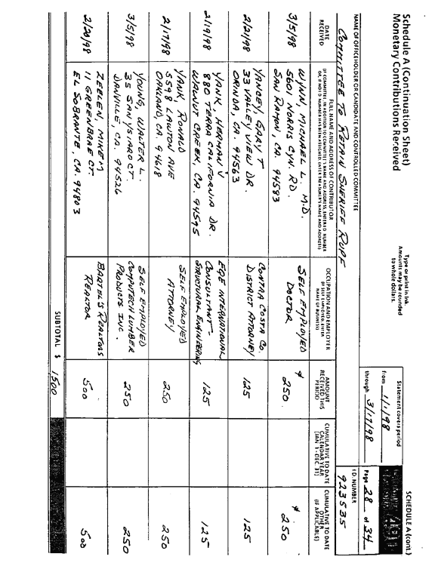
More money from Zeelen and Yancey, in 1998.
Campaign Statement, Page 5:
Horizontal (for viewing online)
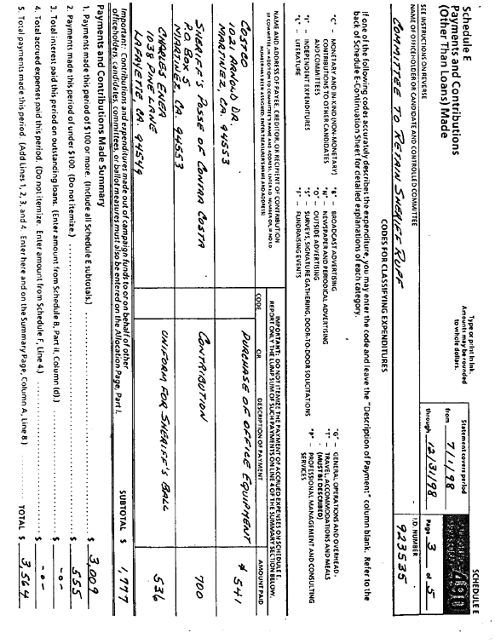
Here's money going from Rupf's campaign OUT to the Posse. Interesting. Note the Posse's mailing address, you'll see that again…
Campaign Statement, Page 6:
Horizontal (for viewing online)
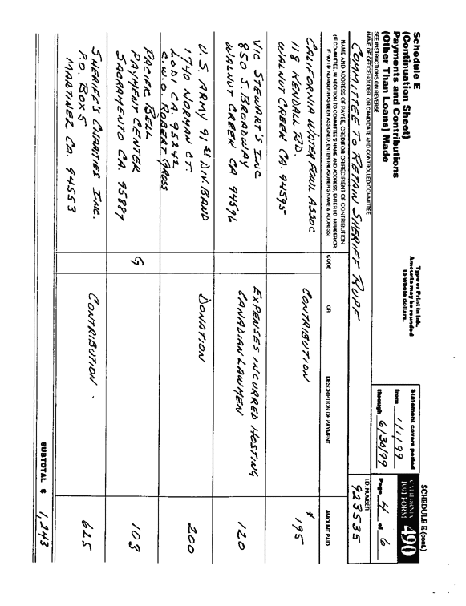
Here's more Rupf campaign money going out the door. Note the address of the "Sheriff's Charities Inc." — same as the Posse's address, previous page.
Now, a cynic might ask whether the money is being properly separated between political org (the Posse) and charitable purposes…but it probably is, there are too many otherwise reasonable people in the Posse for something that ugly to go un-noticed.
The point is, the $700 that went to the Posse by name went for political purposes, because if it had been intended for charity it would have gone to the Sheriff's own charity, instead.
In other words, it's further evidence of how deeply tied to the Sheriff's electoral politics the Posse is.
Campaign Statement, Page 7:
Horizontal (for viewing online)
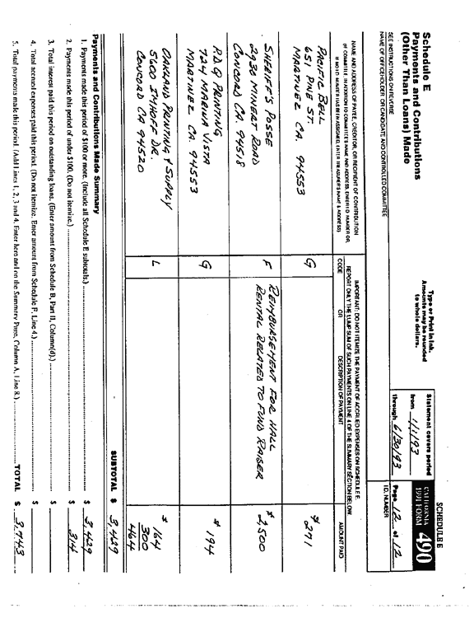
This is interesting — the Posse went and rented a hall specifically for a Rupf campaign fundraiser, and Rupf paid 'em back. Nothing wrong with that, but yet again it shows deep ties between Rupf's electoral politics and the Posse.
And that in turn raises harsh questions about why Rupf's secretary was able to provide the dates and times of Posse events to callers, and direct a Posse applications set to his mailbox.
Campaign Statement, Page 8:
Horizontal (for viewing online)
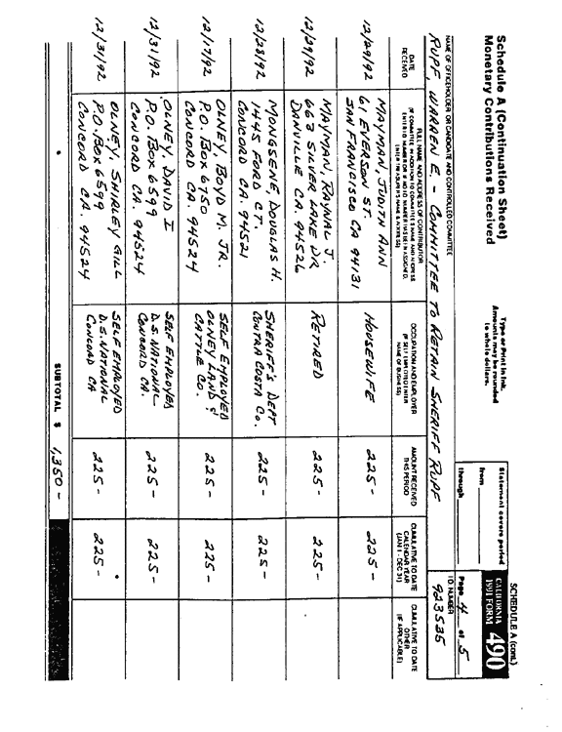
Mayman is a permitholder, and Posse.
Mongsene is now retired; at one point in the mid-1990s he was a Lt. In the Sheriff's department who Rupf assigned the task of "initial CCW screening"…later that went to Lt. Wayne Willett and now somebody name of Varady.
Approximately 1996 a business owner who lives in Lafayette called the Sheriff's office and asked about CCW issuance. Mongsene told the guy to join the Sheriff's Posse if he wanted any chance at all.
(Sidenote on campaign finance laws: per county rules, $225 is the max donation in a non-election year. So Mayman got his wife to contribute too. As for Olney, a total of 8 or 9 different relatives and/or Olney employees all "contributed" in their names on this date — odds are it was really all the owner's money just creatively split. Just like the DeVincenzi contribution of almost $1900 worth of chow — they ran out of relatives to split the total among, and used three employees…who I somehow doubt cared very much about Sheriff Rupf's political career. In other words, it's easy to make up these dumb rules, but it doesn't take much creativity to bypass 'em either.)
APPENDIX A: Rupf Permitholder Database, Circa Early 2000
Version 4.0, cleaned up, page numbers added plus endnotes with some legal technicalities.
Compiled 8/21/01 by James March
Names and case file info is derived from Rupf's response to Chuck Michel's PRAR request of early 2000. Rupf withheld this data in the Fed trial of 2001, we were forced to use the older data, consisting of over 750 pages of mildly redacted (by Rupf or his staff) original CCW application/renewal file info.
Methodology: each multi-page record in the Michel response was examined and the permitholder name compared to the rosters of permitholders dated 5/24/2001.
Their information is summarized in the table linked below. Therefore, this table will be incomplete in that it doesn't cover new permit issuance between the time of the Michel response and 5/24/01. This table is also limited purely to current (as of 5/24/2001) permitholders.
Note: the "first issued" date refers to the first date I can find in the file, and in many cases the oldest forms for that person are missing or incomplete. Permits may be older than as listed. If there's no first date on the file, I refer to the 5/24/2001 PRAR data.
City of residence generally isn't listed because it's wildly inaccurate in all Rupf sources. Somebody with an address of "Martinez" for example may live many miles outside the town borders.
"Numbering" refers to the page number where that applicant's file begins.
Permit types: 12027i refers to the shall-issue system for retired Fed agents. Standard/Std is the normal type, "Judge" is obvious, and
"Reserves" mean a reserve deputy for the Contra Costa Sheriff's Office UNLESS some other department is noted.
Some pages were discarded as irrelevant; we have saved these and will make them available to defense counsel upon request. The pages set aside included shooting range qualification data, sign-off sheets showing that the applicant understands the process, and renewal applications where the renewal pages did not contain any "new information" beyond the contents of the original app and the current permit card itself. In some cases the renewal sheets were retained in the file because they were the only data available, or the renewal sheet expanded on info available in the app, or the renewal sheet showed a change in occupation (or "life circumstances") from the original application time. Examples of the types of pages set aside can be found in pages 743-747 — it is Plaintiff's firm belief that these pages are irrelevant to the charge of equal protection violations or it's defense.
Not one renewal form page ever contained revised "good cause data" from the original issuance.
APPENDIX A: Rupf Permitholder Database, Circa Early 2000
Page number | Name | First Issued | Permit Type | "Good Cause Summary" | Posse? | Misc Info/Notes
4 | William Bruce Plummer | 1975 | Standard | Carries cash related to his photography business (owner). | YES | He also had CCW in Ohio based on a "special deputy status" with no actual law enforcement duties…very similar to the Posse.
10 | Frank Edward Nunes Jr. | 1996 | Std | Needs to defend his cattle ranch, which he owns and resides at. Of course, being his "home and place of business", he already has carry rights. This same PRAR response in the "good cause" area for Steve Jacobsen was heavily redacted; not so for the Michel PRAR response of early '2000. In Rupf's 5/24/2001 permitholder database printout, occupation is "consultant". | YES | Nephew of Frank Pereira, known to be politically connected and a former UnderSheriff and current Posse member and permitholder. References included both Frank and John Pereira, Jack Roddy, Bob Chapman
14 | Richard Earnest Tirrell | 1975? | Std | "Night work, violent crime area", he is a doctor and a nurse was robbed in the hospital parking lot. Posse membership listed in the "good cause" statement! | YES
19 | Lois Haight | 1995 | Judge | Judge - modest good cause listed |  | Listed as reference by Thomas Van Voorhis, #23
23 | Thomas Van Voorhis | 1998 | Std | This is somebody Willett denied in 1998 due to no good cause, so he appealed to Rupf by letter with very weak "good cause" and a long list of Judges and politicians as "character references" - classic "CCW by connections". |  | Thomas Van Voorhis was on a first-name basis with the staff of former state senator Rainey. I filed a complaint with Rainey's office about Rupf's CCW abuse, they mentioned "Thomas" as a frequent visitor. Related to attorney Dan Van Voorhis, attorney for Kenneth Eugene Behring entry #526
28 | Frank Pereira | 1964 | Std | Unknown good cause - old permit, "good cause" papers long since lost, gets renewed anyways. He's a former UnderSheriff political appointee back in the '60s, but wasn't a sworn peace officer hence the need for CCW. | YES | Politically connected - note the pattern of "very old permit and renewals despite no "good cause on file". You'll see more of that.
32 | William Albert Riley Jr. | 1986 - but see notes | Std. | "My wife is in a wheelchair, we're old, we use ATMs" - accurate paraphrase of applicant's own handwritten "good cause statement". |  | This was a renewal; he had a permit while living in Kingsburg, CA 93631, Fresno County (which is highly restrictive). PRAR response printout lists him starting in 1995
37 | Walter Joseph Pastore | ? | Std | "I have to be in SF and other high crime areas at night" - accurate paraphrase. | YES | Pastore is prominently mentioned in Rupf's campaign fund records.
40 | John Lee Pereira | ? | Std | None listed. Former "special deputy Sheriff" | YES | Son of Frank Pereira, Posse, related to Frank Nunes Jr, Posse
42 | Joseph Randall Mass | 1984 | Std | None listed - forms are present, good cause statement area is blank!
46 | Kim Fang (RIP) | 1989 | Std | None listed. When he died, media reports listed his "good cause" as being related to telephone death threats however he had switched both residence and career since initial permit issuance. Media reports of his death widely mentioned Posse membership. | YES | The PRAR response to Michel was done before Fang died. Fang donated at least $700 in recorded campaign donations to Rupf and more than that to Rainey when he was Sheriff and approved Fang's permit.
48 | Robert Henry Martinez | 1990 | Std | He's a "Sr. VP of Marketing" for "Eagle Food Service". Good cause (paraphrased) adds up to "on the road late at night, takes his daughter to sporting events across the state (horse-related)". Wealth involved in issuance?
56 | Owen McNiel Schafer | 1982 | Std | The entire "good cause" section reads: "Self Protection". (He may be a former reservist, see also entry page 66 (Christopher Young) below for what may be a similar case.)
60 | Jamieson Bitzer Bates | 1999 | Std. | Turned down by Willett for lack of good cause, writes four-page rant on the general state of crime plus constitutional rights, and is personally approved by Rupf. I don't disagree, point is Rupf would never have issued to a peon on that basis. |  | Mike Haas met this gent at a political event where Haas was speaking; Bates had much praise for Rupf's CCW policies. This and Van Voorhis establish Willett's involvement in bias.
66 | Christopher Young | 1995 | Reserve | Good cause listed as "Self Protection". That may be standard for reservists? |  | As long as they're still IN the reserves this makes at least some sense. But we have cases on record where they keep the permit even after leaving reserves.
69 | Alex Clyde Smith | 1981 | Reserve | None - it says "issued pursuant to reserve policy" and "will be revoked on leaving the reserves". Well if that’s the case, and numbers 56 and 66 above were reservists from the same period, #56 kept his permit post-reserve.
73 | Michael Stephen Telfer | 1995 | Std | "Travel, including through violent areas with young daughter and luxury car". Accurate paraphrase. Owner of "Telfer/Sheldon Oil Company". |  | Rupf probably saw big potential for campaign money.
78 | Ernest Terry | 1968 | Std | Good cause not present (forms missing, typical of older permits). Occupation: owns a cocktail lounge. |  | Permit expired…he may have died or moved?
81 | Frank Joseph Thelen | 1970 | Std | Here's a good one. He was manager of a slaughterhouse, and had a permit for "personal protection and handling bank deposits". OK, fine…but he's still being reissued, even though he's now a teacher at a community college?
83 | John Peter Toth MD | 1970 | Std | Good cause: "self defense" - that's the whole text
86 | Wayne Roy Tulnage | 1978 | Std | Some kind of HazMat specialist - had a brief encounter with two guys who he thought was watching him take money away from a safe.
91 | Joseph Lewis Venturino | 1994 | Std | Gunsmith transporting guns/money
95 | Ernest C. Voight | 1994 | Std | Real estate person of some sort, drives alone to properties in Nevada.
99 | James Von Waldegg | 1961 | Std | Mortgage Banker - no good cause listed.
101 | Joseph Domenic Vrankovich | 1976 | Std | VP of the Oakland Meat Company needs general protection, I guess due to wealth? He has a sense of humor - on the old form asking for "prior criminal problems that make you seek a permit" he hand-wrote "not yet". | YES | This gent just died, per the Posse newsletter. Also per that document (page 5)he had held the rank of "Lieutenant" in the Posse, but at age 85 he clearly wasn't a reservist.
107 | Denis M. Weigand | 1987 | Std | Owns a vending company, carries money
111 | Claude Samuel Whitson | 1968 | Std | Physician - no good cause listed (forms missing)
114 | Donald Aubrey Williamson | 1959! | Std | Rancher - good cause is "self protection" (entire text)
117 | Michael Lee Wynn | 1994 | Std | Physician - moderate good cause relating to control of drug supplies, prescriptions, disability signoffs.
121 | Raymond Frank Zaharis | 1968 | Std | Owner of the Oakland Meat Company, Vrankovich's boss (#101 above). Other than that, no good cause listed…forms missing, lost in the mists of time. | #101 was.
124 | John Domenic Devincenzi | 1989 | Std | Transports money relating to family chain of Delis. | YES | There's always been at least one member of this family with a permit at any one time, for many years. This family has given over $3,000 to Rupf's campaign funds, and caters Posse dinners.
128 | George Robert Martin | 1993 | Std | Owns business, ex-employee threatened to go postal, plus he responds to the alarm late sometimes.
132 | Dennis Robert Ladd | 1993 | Std | Business owner, three parts stores, two in bad neighborhoods. He had a pretty good list of police reports relating to vandalism, robbery, break-ins. |  | Decent good cause - but being a business owner helps…
137 | Eugene Reyes Abuan | 1974 | Reserve | Seems to have scored CCW before joining reserves. No good cause statements of any sort in file.
139 | Ralph John Alvarado | 1994 | Std | Manages a welfare fraud investigations unit for the county social services department. Has very strong good cause related to a psycho ex-employee, documented very well. |  | We have no way of knowing how many "regular folks" in circumstances just as dire were denied…esp. if they lived in a town with it's own PD.
146 | Joseph John Ambrosino | 1985 | Std | Geologist by trade, also has rental properties, claims tenants being thrown out threaten to kill him.
150 | Armand Albert Annereau | 1972 | Std | Owns an auto upholstery shop in a "dark secluded area", carries cash. |  | This is specifically the type of good cause Varady said was inadequate to the Contra Costa Times.
152 | Leonard Lewis Battaglia | 1971 | Std | Owns a liquor store
154 | Roger Lee Becker | 1973 | Std | Originally he was the asst. manager of a sporting goods store and took money to the bank. He has switched to some unspecified "self employed", no details.
156 | Robert William Betti | 1974 | Std | Originally got permit restricted to the times he was carrying money relating to his plumbing business. That restriction has been lifted some time since. He's still in that trade.
158 | Guy Henry Black | 1969 | Std | Contractor, something to do with radio/TV broadcast antennae, works in remote areas. Weak.
161 | Ernest W. Blee | 1965 | Std | Civil engineer, no good cause listed.
163 | Robert Hayden Chapman | 1974 | Std | Rancher - no good cause listed, forms missing. | YES | Chapman was a reference on the Nunes application, alongside the Pereiras.
165 | Francis J. Castle Jr. | 1993 | Std | Owns "Castle Fine Arts" in SF, other than that no good cause is in the file (the forms that would have it are gone).
167 | Salvatore Cardinale | 1980 | Std. | Farmer - "for protection of large sums of money".
170 | William Allen Davis | 1997 | Std | Owns some sort of business, can't make out the name. Paperwork is particularly sketchy for a Rupf-era initial permit, all forms that would have good cause on 'em are gone. Yet there's been at least three renewals, the latest early in '99.
172 | Gail Anthony DeMartini (male) | 1984 | Std | A stockbroker whose stated "good cause" was for protection while at a remote ranch in Calaveras County. There was a more detailed letter, now missing. |  | Note that the permit was NOT geographically or otherwise restricted.
177 | Angelo Dimaggio | 1974 | Std | Owner of a business called "Elegant Floors", no good cause statement papers, as normal for files this old.
180 | Michael Edward Donnelly | 1997 | Std. | Same as #170 - business owner, sketchy paperwork, multiple renewals since. ALL original papers gone, along with good cause, not common for Rupf-initial-issued permit.. |  | Very odd. Steve Jacobsen filed a PRAR on Rupf in 1997 - it's possible Rupf's people started realizing there was damaging stuff in these files around that time, and purged 'em?
182 | Lawrence Delmore Durbin | 1975 | Std | Sketchy papers, no good cause info, he used to be the head custodian for a local school district, and as of 1998 he was retired and still being renewed. |  | Some sort of connections involved.
185 | Robert August Edelman | 1995 | Std | Business owner, was dealing with petty crimes near his warehouse, and when he made contracting housecalls he dealt with criminal-class people (he referred to a house as having guns and drugs exposed in the living room).
187 | William Ellis | 1999 | Std | Doctor, runs multiple offices, deposits cash.
189 | Giovanni N. Epifani | 1978 | Std | Owns a Ferarri dealership/repair shop, travels with race cars.
194 | Michael Geary Farrell | 1972 | Reserve | He's been a reservist the whole time he's held CCW. |  | As usual with reserves, no "good cause"
196 | Douglas Lovejoy Faulkner | 1977 | Std | He's a sales engineer for "steam specialties", and travels to Richmond, where "punks" of some sort threw rotten veggies at his car four years ago. Weak.
200 | David Allen Flori | 1971 | Std | No good cause records. When he first obtained CCW, he was a frozen foods salesman, now he's in sheet metal somehow.
202 | Dale Allen Frost | 1992 | Std | Real estate investor, goes to "low rent" areas.
206 | Barton Jay Gilbert | 1997 | Std | He's a Brigadier General in the US Army Reserves, and is sometimes connected with drug task force operations. Not bad as far as "good cause".
210 | Frank Wendel Greer | 1971 | Std | Masonry contract estimator, carries large sums of cash for banking and payroll? Which doesn't make much sense…that's not what you'd expect an estimator to do.
213 | Joel H. Golub | 1993 | Judge | Court commissioner, good cause relates to that.
217 | George James Grover Jr. | 1990 | Std | Good cause is "we live in a remote area of Orinda, have lots of money, art and valuables, and we travel to art shows".
221 | Roger Marion Gorrell Sr. | 1975 | Std | Employed originally as a PI for an investigative agency, now "self employed", job title not specified.
227 | George Charles Heitman | 1990 | Std | Attorney, does family law practice and had specific threats. Strong good cause case.
233 | Roger Dale Henderson | 1973 | Std | Owns auto parts store, takes cash to the bank.
236 | Andrew Claude Higgins | 1994 | Std | Internal security and executive protection, employed by Bank of America
240 | Joseph Hisquierdo | 1998 | Std | Private Investigator/bodyguard/POST course instructor
243 | William Albert Howard | 1994 | Std | Construction foreman, takes payroll to remote sites.
247 | Deborah Michael Jacob | 1997 | Std | Senior security manager for Bechtel, internal corporate bodyguard.
250 | Wayne Edward Jackson | 1985 | Std | Gun shop owner, sells full-auto machine guns to PDs. Needs to be able to defend same from being stolen.
254 | Alexander Williams Jason | 1985 | Std | PI, plus carries cash to sporting events he manages.
259 | Kenneth Allen Krohn | 1991 | Std | Other than occupation listed as "repossessor", no good cause statement, very skimpy file.
261 | Michael Patrick Keenan | 1983 | Std | Corporate security, loss prevention for Ross stores. Originally scored CCW while doing the same for Macy's.
266 | Richard Jacob Karnes | 1970 | Std | Something to do with an auto wreckers - owner? Most of the old paperwork and good cause data missing.
270 | Dennis Spencer Kahane | 1996 | Reserve | Good cause mentions working late with "most unsavory" (his words) people hanging out in the parking lot - he's an attorney. |  | Kahane in an official in the Posse.
273 | Robert Denny Laurence | 1992 | Reserve | Good cause relates to being a reservist.
278 | Christian August Lauritzen III | 1985 | Reserve | Original CCW issued because the guy runs a yacht harbor. |  | I wonder if Rupf judges wealth purely by the applicant's name?
282 | Lowell Stanley Lawrence | 1979 | Std | Security and executive protection for PG&E (his employer). |  | Considering PG&E's current popularity, I'd assume he's pretty busy.
286 | James Donald Lee | 1972 | Std | Sells guns and tear gas to police departments, at least back in '72. Current permit lists occupation as "sales".
289 | James Robert Lobb | 1996 | Std | Occupation on most recent permit is "salesman", ALL original papers missing including "good cause".
292 | David Arthur Long | 1972 | Std | Attorney in his original papers…no other good cause, and he's now retired. |  | Especially interesting. Original papers are marked "transfer", good cause left blank. The guy has had continuous renewals since, and at NO time has the Contra Costa Sheriff's Office ever had a good cause statement for him on file. And now post-retirement, CCW is STILL being treated as a "tenured position". Equal protection violation.
294 | Michael James Lorenzo | 1998 | Std | All original "good cause" papers and documents from the original 1998 application are missing, odd for something so recent. lang=FR style='font-size:10.0pt;font-family:Verdana;'>Occupation: P.I.
296 | Walter Lloyd Lyall | See note! | Std | Runs a security company now; back in 1970 was involved in a home/apartment maintenance company. |  | The oldest papers from 1970 are for a renewal. As with #80, Rupf never had good cause data for this guy, ever?
299 | Michael George McDermott | 1972 | Std | Owns small business, carries cash to bank.
302 | David John McIntyre | 1992 | Std | Employed in corporate security, department director.
306 | David Ewing Maclellan | 1979 | Std | Owns a construction company, carries cash to $8k, and had death threats from a violent ex-employee.
311 | George Kevin Mallett | 1993 | Std | Attorney, also a Judge Pro-Tem and Superior Court arbitrator.
316 | William E. March | 1971 | Std | Originally a county animal control officer, now retired. |  | I'm not related to him so far as I'm aware.
318 | Ronald Pete Massei | 1998 | Std | He owns a restaurant and a vending machine company, works late and transports cash.
320 | Raynal James Mayman | 1978 | Std | He's a financial manager with Bechtel, described as "a major multinational firm that does business in "world hot-spots" such as Iran, South Africa, the middle east, etc and the company is a target of anti-nuke people, environmentalists, etc." (paraphrased) and therefore he's at risk. As a financial specialist, he probably never leaves this area on business, if Bechtel gets targeted it'll be overseas. | YES | Mayman is treasurer of Rupf's campaign fund, and seems to have held that position throughout Rupf's tenure as Sheriff.
325 | Paul Euper Meadors | 1968 | Std | Owns a restaurant chain.
328 | Jack Mattew Metez | 1961 | Std | Former building contractor, now retired, no good cause papers in the file. |  | Another case of "tenure", no good cause needed.
331 | Louis Maximillian Meunier | 1994 | Std | President of Macy's West(!). Claims to be well-known for pushing prosecution of rioters in SF that were active after the Rodney King verdicts. |  | What are the odds this gent's wealth and social status had something to do with permit issuance?
335 | Frank Louis Middleton | 1988 | Std | Owns a welding supply business, carries cash, etc.
340 | John D. Milano | 1985 | Std | Chiropractor, gave story about his mother's house getting broken into and her purse stolen, so despite not living with her, somehow his gun is going to help her. |  | Rupf should have issued the CCW to granny!
344 | Sandra Ford Mock | 1994 | Std | Attorney, received threats related to a case
348 | John Andrew Montagh | 1974 | Reserve | No good cause data; this gent is Rupf's Rangemaster and from what I've heard separately, very competent at it. |  | He doesn't appear to be a "roadblock" in the CCW process. Probably generally pro-CCW. How much he knows about bias/elitism/etc is another question, might be interesting to get him into depositions?
350 | Charles James Morehouse | 1973 | Std | Attorney, "needs to be on the street with his police clients". |  | He's now with a different law firm, it's unlikely he has the same needs as in '73.
353 | Robert Anthony Nadol Jr. | 1970 | Std | Originally a truck dispatcher (with the Teamsters Union?), now in construction - the only "good cause" statement was "self protection". |  | No "good cause" details ever on file with this guy. I smell a politically connected individual.
357 | Tarchieso Joe Piastrelli | 1969 | Std | Now retired, was in sheet metal, good cause missing from file.
360 | David Pearsall Platter | 1969 | Std | Current permit has occupation as "Finance", back in '69 he was a stockbroker for Merrill Lynch, still works for that company in some capacity. No good cause on file.
363 | Calvin Vincent Porter | 1968 | Std | In '68, he was into carpet sales and was a full-time fireman. Occupation today is "Sales", and no good cause data is in the file.
366 | Garry Joseph Russello | 1994 | Std | Owns Pacific Electrical Supply Inc, claims to have to fire people sometimes, and they get disgruntled.
371 | Walter Rosenkranz | 1988 | Std | Dentist does 24hour emergency care, and has access to drugs.
375 | Joseph Petere Remiti | 1979 | Std | Carries money to buy Corvette parts and cars as part of his hobby. |  | Sounds politically connected.
380 | Jack J. Sarver | 1995 | Std | Retired; as of 1995 he was doing some estate jewelry sales on the side, claimed an undocumented attempted robbery. Don't know if he still does this as a retiree. |  | Compare this to Derek Westfall's case - Derek couldn't get full documentation out of Orinda PD so he gets shot down.
383 | Leo Saunders | 1991 | Std | Real estate, and does rent collection for property management purposes, so carries cash.
387 | Darrell Santos | 1998 | Std | Works in investigations for PacBell, coordinated wiretaps and testifies in state and Fed court. Claims to have received threats for that stuff. |  | Transferred from Alameda Sheriff's Office.
390 | Maurice Herbert Rose | 1991 | Std | Self employed coin and precious metals dealer at shows, transporting valuables.
395 | Thomas Michael Powers | 1978 | Std | Live one! Scored CCW while a member of the CC County Board of Supes, talked about having to go mix with his constituents(!). Also an attorney who handles estate sales, etc. | YES | This guy was known for his strongly anti-gun ways while in office(!) as was his wife who was on the Richmond city council. Hypocrites!
400 | Edward Gerow Symmons | 1997 | Std | Business owner, carries cash, business not named - odd |  | Most list businesses owned.
403 | Thomas Andrew Sutak | 1982 | Std | VP of a security company, does executive protection
408 | John Dean Shipley | 1961 | Std | Retiree today; at time of issuance, was a machinist and did some gunsmithing and shooting instruction. No good cause statement on file.
411 | Joseph Siino | 1971 | Std | Attorney (still practices). Statement in 1971: "Carry large sums, also represent different types of people" (exact quote). Now, to my knowledge, there's just one type of people on the planet, now that Neanderthals are extinct…
414 | Gary Allen Smith | 1972 | Std | Owns an auto body shop, good cause: "self protection and large sums of money" (exact quote).
417 | Harold Bernard Smith Jr. | 1964 | Std | Owns retail stores - no good cause data on record.
420 | Ronald L. Smith | 1997 | 12027i | Former cop, deputy and FBI said he wanted to break into executive protection.
422 | Timothy Charles Smith | 1993 | Std | Runs retail insurance biz, takes cash to bank.
426 | William H. Smits Jr. | 1994 | 12027i | Former FBI, 23 years, "to protect myself from the people I busted" (paraphrase).
430 | Roy Douglas Snelson | 1973 | Std | In '73 he was a "garage foreman", no good cause is listed anywhere, and his latest renewal has the "occupation" area deliberately masked out.
433 | Michael Stephen Stone | 1977 | Std | PI/bodyguard.
439 | Robert Warren Nagle | 1984 | Std | CPA, transports cash for one accounting client. |  | Does he still have that client?
445 | Erik Strand | 1993 | Reserve | Reserves is sole good cause.
460 | Roger L. Draper | 1999 | Reserve | Good cause relates to reserves, he does some work as a jailer in Martinez, worries about revenge by ex-inmates.
463 | Stanley Edwin Gutman | 1996 | Std | Wealthy corporate attorney, travels through SF, poor delicate flower.
467 | Richard Charles Dubruille | 198? | 12027 | Retired FBI, now a PI. |  | This is the guy that put "Walnut Creek PD doesn't issue any permits" in his application. He had no reason to lie.
471 | John Walter Challoner | 1999 | Std | This one's important. No good cause data. Thing is, this guy transferred in from Clayton PD, approved by Lt. Willett 2/2/99. Clayton PD told a different applicant that they don't issue at all, in 1996. And this guy is a VP in Seeno Construction - Mr. Seeno holds a CCW, and Seeno is definitely Posse. | 99.9% certain | Seeno is deeply connected to DA Gary Yancey, now retiring due to cancer.
473 | Tom Butterfield | 1992 | Std | Union district representative when issued, good cause was "Do business and attend social functions with my wife and sometimes my children in high crime areas of Contra Costa County" (verbatim!). Now he's retired, and a pathetic effort was made to cover that up (see the Michel file record pages 473-478). |  | Politically connected!
479 | Phillip Eugene Bradshaw | 1962 | Std | No good cause data in file. Original occupation was as a salesman for International Harvester - now retired. |  | Another "tenure case"
482 | Leonard Raymond Orr | 1967 | Std | No good cause on file, continuous renewals, he's a GOLF PRO?
485 | Roger Denton Working | 1994 | Std | "Protection while traveling in high crime areas ie: Richmond, West Oakland, East San Jose" (verbatim!). |  | Remember, Richmond is a specific zero-CCW zone - if you live there! Richmond was blocked by agreement between Rupf and all the PDs in the county, where Rupf wouldn't issue in towns plus Richmond's Chiefs have always been anti-CCW.
488 | Norbert Young | 199 | Std | Specific claimed threats that add up to fairly strong good cause, no documentation on it. |  | He may be a Richmond resident, uncertain without knowing the street address.
490 | Marinus Zeelen | 1994 | Std | Realtor; claim of a specific criminal threat plus "carries cash" (business related?). | YES
495 | John Maitland Lauderdale | 1961 | Std | Retired as of 1998; original good cause missing, as of 1971 he was an "account executive" for an electrical sign company. |  | Another "tenure case"
498 | Edward L. Kronick | 1969 | Std | Doctor; no good cause statement, records missing.
502 | Steven Mark Elefant | 1991 | Std | Occupation on current permit is "Executive", good cause statement is missing…there was an attached letter that he referred to in his 1991 application, now missing.
508 | Paul Thomas DiGaudio | 1971 | Std | Occupation: psychiatrist; good cause related to carrying of money? |  | How many people pay shrinks in cash?
511 | Barton Randy Blumberg | 1990 | Std | Oral Surgeon. His good cause statement talked about bad areas, and protecting drug supplies, however… |  | His personal letter to Rainey talks about what a good shot he is, and mentions his shooting buddies: John Montagh (the rangemaster), John Dashner(?) and - WARREN RUPF prior to his election to Sheriff. Very Connected.
518 | Edward Joseph Amarant | 1967 | Std | Occupation is "sales", all good cause data missing from sketchy file. Oldest doc in the file is a 1971 renewal, the "1967" date comes from Rupf's database printout.
521 | Donald A. Stewart | 1983 | Std | Currently retired; all original good cause papers missing. Don't even know what his original occupation was.
524 | Bradford True Prescott | 1992 | Std | Physician - no original permit app forms in the file, no good cause, no nuthin'.
526 | Kenneth Eugene Behring | 1992 | Std | Occupation is "investor", the complete good cause statement is "high profile…need protection". Works for "Blackhawk Corp" in CCW application file… |  | Scratch "works for" - Ken Behring not only owns "Blackhawk Investments", he also owned the Seattle Seahawks NFL team fairly recently, owns the Behring auto museum, and he personally built the city of Blackhawk. During the political wars surrounding the Blackhawk development, his attorney was Dan Van Voorhis, related to current permitholder and crony Thomas Van Voorhis. Ken Behring is a multi-billionaire, one of the richest men in Contra Costa County, and it's interesting that the phrasing of the application sought to mask this.
531 | Nelson Buck McAfee | 1989 | Std | CEO of the Oakland Meat Company, originally scored CCW because he was the Chief Financial Officer and did bank deposits but with the job title change, that "good cause" is gone now. Doesn't matter, he's an aristocrat, right? |  | We know of two other permitholders (#101 and #121) connected with that corp. Permit application was witnessed by Vrankovich, #101, who's known Posse.
539 | Gregory Allen Reese | 1997 | Std | This guy works for his parent's political consulting business; he leads teams of canvassers into "bad areas" and many of his team members are women. |  | Think about this: wouldn't it be greatly to Rupf's benefit to have THIS sort of person "owe him one"? And of course, people who LIVE in the bad areas are blanket-denied.
542 | James P. Muglie | 1998 | Std | Occupation is blank. Original application form is present, but good cause is BLANK. |  | This one is really odd…Rupf renewed him on 5/7/99, not long after I sued him. Rupf had to be at least peripherally thinking about "good cause" and equal protection? Yet he signs off on this?
545 | Ann B. Moriarty | ? | Std | Property Manager; there's no good cause statements, no original applications paperwork, and she's not in the database that covers original dates of issuance.
547 | Stephen James Mikich | 1999 | Std | Business manager, lame good cause involving "contact with large sums of money" and "travel through high crime areas". |  | Application was witnessed by Frank Pereira, known Posse.
549 | Melvin D. McCollough | 1972 | Std | Now retired; used to be a warehouse foreman, original 1972 form is present but with "Good cause" was BLANK
552 | Donald Lee McCulley | 1972 | Std | Originally he was VP and sales manager of a manufacturing company. He now runs his own manufacturer's rep sales firm; good cause involves business cash. His 1972 letter to the Sheriff lists the UnderSheriff as a personal character reference. |  | Definitely a connected individual.
556 | Robert Leon Hawkins | 1978 | Std | Former cop, now a PI. |  | If he retired, it would be a 12027-type permit? (12027 is a shall-issue system).
561 | Stanley Joseph Hennessey | 1993 | 12027i | Retired FBI
566 | John James Jonopulos | 1993 | Reserve | Good cause relates to reserves.
571 | Stephen J. Limrite | 1993 | Reserves | Reserves
576 | Ilir Nushi | 1996 | Reserves | Reserves
579 | Robert William Parkins | 1993 | ? | Originally reserves, obtained CCW purely on that basis, but now he's NOT and still has a permit!?
584 | Dennis Ray Prasch | 1996 | 12027i | Former FBI
586 | John Parker Roland | 1994 | 12027i | Former FBI, now PI
591 | Gene Edgar Ross | 1998 | Reserves | Reserves
593 | John T. Rotolo | 1988 | Reserves | Reserves
598 | Lowell Edwin Richards | 1995 | Std | Attorney, Judge Pro-Tem and does security(?).
601 | William Arthur Rice | 1995 | Reserves | Reserves (Alameda County SO).
606 | Carl N. Reynolds | 1998 | 12027i | Former FBI
608 | Robert Randolph Rockwell | 1974 | 12027i | Odd case - he first obtained CCW off from the Contra Costa Sheriff's Office as a private security guard, then went into the FBI for a long time, and on coming out applied under 12027i. Doesn't matter much, just odd.
611 | Kevin Blair Thomas | 1998 | Std | Prosecutor, Alameda County DA's office.
613 | Bobby Dwain Thomson | 1999 | Std | Internal security and executive protection for Bank of America.
615 | Benedict James Tisa | 1996 | 12027i | Former FBI
618 | David Jon Travers | 1995 | Reserves | Reserves
621 | William C. Vencill | 1993 | Std | Attorney, former cop with Concord PD, "runs into people he busted" (paraphrase). Had a letter of support from the CPD Chief, now missing.
625 | John R. Verducci | 1969 | Std | Barber shop owner - good cause statement not present.
627 | Albert Kaye Watts | 1983 | Reserves | Reserves
632 | Walter Mills Welti | 1988 | Reserves | Reserves
637 | Vincent Joseph Weltz | 1998 | 12027i | Retired FBI
639 | Dirk Peter Walzien | 1999 | Std | Restaurant owner, takes money to bank, threats from violent/crazy ex-employees.
641 | Ronald A. Witney | 1995 | 12027i | Retired FBI
645 | James D. Wilson Jr. | 1998 | 12027i | Retired FBI
647 | Owen Kieth Yeager | 1971 | Std | Originally scores CCW as reserve, retained CCW after leaving reserves. Occupation is blanked out on latest permit.
650 | Richard Albert Zarzana | 1990 | 12027i | Retired Fed Secret Service
658 | Robert Allen Fink | 1989 | Std | Trauma room neurosurgeon; has testified as to the nature of injuries inflicted by criminals and is not popular in certain low-rent circles as a result. |  | Decent good cause statement
664 | Edgar Leon Aitken | 1999 | Std | Financial consultant and auditor, claims that this makes him unpopular at times. Also claims to carry money. | . | Moved in from Napa, where he had CCW for 15 years. Mentioned that the Napa Sheriff would act as a reference.
667 | James Hugh Anderson | 1978 | Std | Assistant DA, deals with gang prosecution.
673 | Stephen Keith April | 1988 | Std | Fire/arson investigator, local fire district. |  | Decent good cause
679 | M. Donald Bellew | 1978 | Std | Former cop in New Jersey; employed as internal security and executive protection for World Airways, which if I recall right, is now defunct? Current occupation is listed as "security mgr."
685 | John Felix Bessols | 1998 | Std | Owns 100 apartment units, collects rent, takes cash to bank.
687 | Edward George Borden | 1996 | Reserves | Reserves - Berkeley PD.
690 | Wilfred Carnell Broom | 1994 | Reserves | Marin probation officer and has deputy powers somehow connected with the Marin Sheriff.
693 | Robert Duran Burke | 1994 | Std | Deputy DA assigned to a gang task force.
700 | Bruce Murray Croskey | 1984 | 12027i | Former Deputy US Marshal, now getting threats.
705 | Carl Herrick Critz | 1999 | Std | Pathologist, testifies about cases, had letter of reference from the San Joachin County Sheriff - who mentioned Critz as being Contra Costa Sheriff's Posse. | YES | Remember, Rupf's lawyer was on record in court on 12/22/99 saying that the Posse is a private political club whose membership lists should be sealed.
708 | Janet Candis Collins | 1999 | Reserves | Reserves
710 | Ernest A. Clausen | ? | Reserves | Reserves - paperwork particularly sketchy.
712 | Paul L. Cianciarulo | 1999 | Std | Occupation is "estimator manager", good cause is "I'm a former cop, I may run into people I busted" (paraphrased).
716 | John Robert Davison | 1971 | Std | Original good cause: "hardware salesman on the road a lot with valuables", occupation today is listed as "sales".
719 | Gerald B. Diedrich | 1996 | 12027i | Retired FBI
724 | Fred T. Fiedler | 1994 | 12027i | Retired FBI
729 | Michael Abram Garduno | 1996 | 12027i | Retired FBI
731 | Grady Lee Goldman | 1990 | Std | Criminology lab technician/manager, testifies in court, needs protection.
735 | Thomas Lewis Hauschild | 1999 | Reserves | Reserves - former full-time deputy, now a firefighter.
737 | Michael Chance | 1983 | Std | Retail gun shop owner.
743-747 |  |  |  | These are examples of pages from the file Rupf supplied Chuck Michel that Plaintiffs and counsel have set aside as being not relevant to the subject of equal protection.

Additional Notes
The 12027-based permits shouldn't even be in here. That's a separate system for former law enforcement of various types — 12027i covers former Feds. Now, I'm not ready to call 12027 an equal protection violation, because to do so, I'd have to challenge the idea that cops get armaments and carry rights beyond what "us peons" get. A purist might say that, and with some constitutional backing but that's a complexity beyond what I need to deal with.
By including 12027 cases, Rupf gains by "watering down" the percentage of "cronies" listed. Let's say there's a total of 100 Posse members with CCW (which is very conservative!). If there's 244 permits total active today, then the Posse percentage is bad, but possibly survivable. But if out of 244 total, 50 or more are 12027, then the REAL Posse percentage is higher — 100 is a higher percentage of 190 than it is 244.
Problem: it's not at all clear that records under 12027 are public! They weren't covered under CBS vs. Block, and with their shall-issue status, equal protection is less of an issue. I'm not at all harmed if I'm denied info on them.
Last, this file is very incomplete. There were over 230 permits outstanding at the time this PRAR was answered, over a dozen of these in the above database are expired, so there were at least 40 or so files totally missing when this was answered!!! Where the hell are the rest!? I'm going to have to carefully sort out who's missing. There's been some added since, a bit over a dozen. Kim Fang died, of course.
SEE ALSO THE "CONTRA COSTA CRONIES ROSTER" AT: http://www.ninehundred.com/~equalccw/cccr.pdf (for examples of the CCW application files mentioned)

Other Reports Exposing California's CCW Corruption
CCW in Marin County, California: Government Employees Win 3 to 1.
Original Research, Concept and First Draft: Jim March
Edits, HTML Layout, and Co-Author: Angel Shamaya
Oakland, California: ZEN AND THE ART OF CCW ABUSE
by Jim March
Other Reports by Jim March
Fraudulent Gun Control Politics At The Million Mom March
by Jim March and Nadja Adolf
MMM Fraud Followup!
Gun Control Inauthenticity Runs Even Deeper
by Jim March

